Instruction (Manual) Document

Date: Thursday, 13 August 2015

At the time of writing our website is still under construction, but your points will be counted and can be used with us anyway even now.

Guide line for the author for submitting written or video manuals and instructions

1. Potential Topics to create a written or video manual and instruction
- Any introductory topics related trading and investment
- Any introductory topics related Meta Trader 4 or Meta Trader 5 usage or any other trading platform
- Any manuals or instructions related to our software usage in parts or in full (Price Breakout Pattern Scanner, Harmonic Pattern Plus, Sideways Market Analyser, etc)
- Translation of existing manual into different languages (English, Chinese, Korean and Russian are acceptable at the moment.)

2. Reward for your writing
On our website 10 points are equivalent to 1 US dollar and this points can be used to purchase any of our products or service. For example with 500 points, you can purchase 50 US dollar worth of internal products from our website.
- You will receive 50 points to 500 points for submitting written manual or instruction.
- You will receive 100 points to 700 points for submitting video manual or instruction.
- The rewarded points can be used to purchase our internal software or service but we don't directly give out the cash for your points.

3. Advices for your writing
In general, manual or instruction should aim to provide clear demonstration. Therefore, you will receive more rewarding points when your writing or video clips are much more catch and understandable.
- Writing manual or instruction is often good idea for yourself to learn. Best way of learning is in fact to teach other people.
- Manual or instruction must be written in simple layman’s term and in plain language.
- Better to include many diagram or screen shot for clear presentation.
- Clear labelling for diagram and screen shot is important.
- Start writing your instruction from page 6. Use font size 11 and use normal margin.
- Article type of writing is fine too as long as they have the full purpose of writing with good presentation.
- Simple or short manual or instruction is fine because there are many starters looking for step by step guidelines.

4. Minimum Criteria for submitting written materials.
If your submitted materials meet following criteria, you will receive at least basic points to your accounts mentioned in section 2. Please read the following criteria carefully before you start writing.
- For a written manual or instruction, the writing must be greater than 4 pages.
- The points will be assessed carefully by our internal team using our own criteria.
- The sender (author) must agree to publish for the written material on our website.
- Although we will accept your written manuals most of time, we may not publish them on our website without disclosing the reason. In such a case, you will still receive points.
- If we believe that the submitted manuals are too poor quality in terms of demonstration, we may reject them.
- The submitted material must be clean from copyright issue and we are not responsible for any copy right issue for your submitted documents. So it is best to submit materials created by yourself. When you translate other existing documents into another language, you must ask the original author for the permission to publish on our website.

5. Minimum Criteria for submitting video materials.
If your submitted materials meet following criteria, you will receive at least basic points to your accounts mentioned in section 2. Please read the following criteria carefully before you start writing.
- For a video manual or instruction, the length must be greater than 5 minutes.
- The submitted video material must be downloadable by us. So we can publish your video on our YouTube channel. Therefore it is best if you just upload the video on your account on YouTube.
- The same criteria of C, D, E and F of Section 4 are applied for the video manual and instruction.

6. Sample Topics
Here we give some ideas about, what could be possible topics for your writing. Even very simple subject can be topics of your writing too. For example,
- How to use History centre in Meta Trader 4 terminal
- How to use Candlestick pattern detection features in Price Breakout Pattern Scanner
- How to trade Potential Reversal Zone of Harmonic Pattern Plus
- How to set up Forex account with brokers
- How to gauge entry and exit timing using RSI and Renko chart together
- How to use Meta Trader 5 terminal strategy tester
- How to start to trade with binary option
If you have a really good trading strategy you want to share, then you can also create its step by step process in several words page. For example
- How to trade candlestick reversal pattern and continuation patterns showing your own example trade entry and exit marked on your chart
- How to use Sideways Market Statistical Analyser with improved setup with your own example trade entry and exit marked on your chart
- You know that sniper trading strategy is working very well but at the moment it is available in Russian only, then you can translate them into English.
If you have any creative ideas or theory about trading and investment, you can also present the idea with us here too. For example,
- If you have some view about cloud computing and you believe that there is innovative way to help your trading using cloud computing
- If you have some view about social trading and you believe that there is innovative way to help your trading.

Please zoom in to see our products. Our product is normally avaiable on both MT4 and MT5. But you don’t have to write about our products. You can also write about our products without buying them because you can test most of our products on the Market tap in your Meta Trader terminal. Some product may not be fully testable on your strategy tester because strategy tester have some limitatation in its testing ability. In such as case, you need to have the product to product the written or video mateirals.

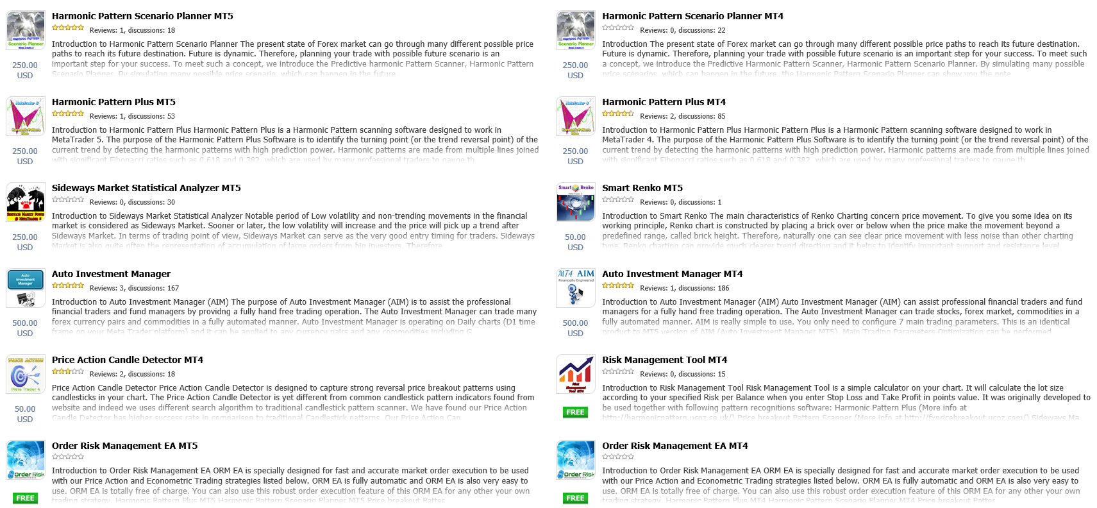

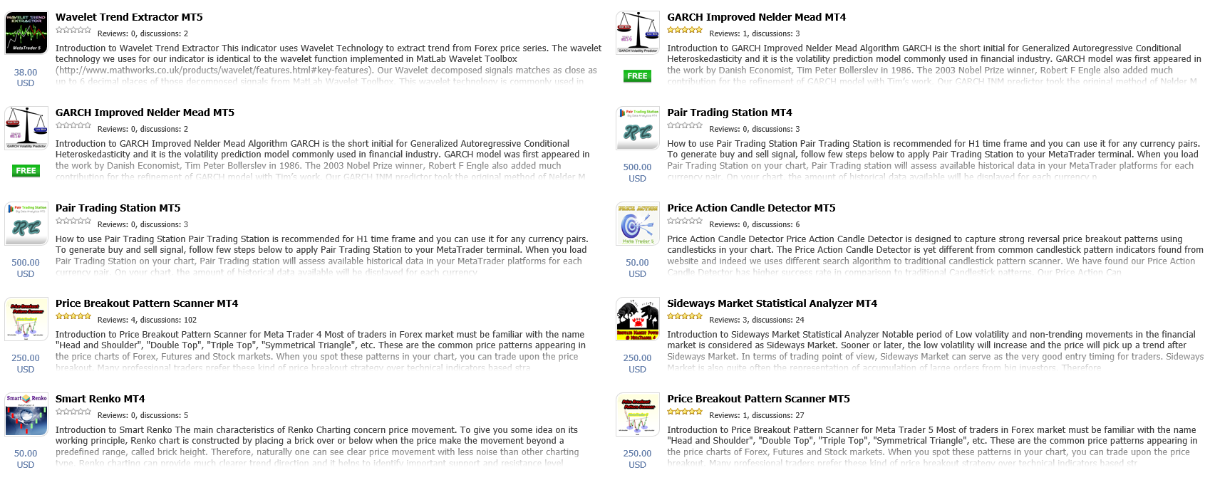

Below Table 1, 2 and 3 should be filled by author before your submission:

- Personal Information
Your Surname
Your First Name
Your Country
Your Email Address
Your ID on our website
Do you want to disclose your name on this publication (Yes or No)
Do you want to disclose your email address on this publication (Yes or No)

- Information for the submitted materials
Title of the submitted instruction or manual
Language of Instruction
Key words (at least 3)
Do you want to disclose your name (Yes or No)?
Do you agree to publish this to our website (Yes or No)?
Does this materials are free from any copy right issue (Yes or No)?

- If it is about any trading platform or any of our products (leave empty if you don’t use)
Name of Trading Platform
Trading Platform version
Name of Product
Product version

Keep Page 1, 2, 3 and 4 with your writing on this word file. You should start to write from page 4 to onwards. After completion of writing, please submit this document to Capital Algo Trading Research to receive your rewards on:
captialalgotradingresearch@gmail.com
Or
financialengineerpro21@gmail.com

We will publish your written or video materials on our Education section on our webpage.

[Please write your instruction or manual from here. You can make your own cover sheet. Literarily you can write anything as long as it has full purpose with clear presentation and they are related to trading and investment. ]

